**RingdateR Beta V1**

**Help File**

**Contents**

|  |  |  |
| --- | --- | --- |
| **1.** | **Purpose of RingdateR** | **2** |
| **2.** | **Starting RingdateR** | **2** |
|  | **2.1** Running analyses | **4** |
| **3.** | **Loading data** | **6** |
|  | **3.1** Loading data in the Pairwise Analysis Browser. | **6** |
|  | **3.1.1** Using Excel and Comma Separate Value files (.xslx and .csv) | **6** |
|  | **3.1.2** Using two column format files (.txt), | **7** |
|  | **3.1.3** Using Image Pro Line Profile Series files (.lps) | **7** |
|  | **3.1.4** Using CooRecorder files (.pos) | **8** |
|  | **3.2** Loading data for Chronology Analysis Mode | **8** |
| **4.** | **Detrending** | **9** |
| **5.** | **Crossdating** | **9** |
|  | **5.1** Lead-lag Analysis | **9** |
|  | **5.2** Running lead-lag Correlation Analysis | **10** |
|  | **5.3** Checking for Problematic Samples | **11** |
| **6.** | **Aligning samples** | **12** |
|  | **6.1** Pairwise Analysis Mode problem sample evaluation | **14** |
|  | **6.2** Saving data | **15** |
| **7.** | **Alternative uses for RingdateR** | **16** |
|  | **7.1** Using RingdateR to compare multiple chronologies | **16** |

**1. Purpose of RingdateR**

RingdateR is designed to facilitate visual and statistical crossdating of tree ring and growth increment width series of both live- and dead-collected samples. RingdateR has a particular focus on facilitating the crossdating of dead-collected samples, with unknown antiquities, either against each other (i.e. pairwise analysis) or an existing absolutely dated chronology. As RingdateR is a crossdating application, it has not been designed for the construction of chronologies and as such does not contain facilities for performing regional curve standardisation or signal free detrending or more sophisticated tools for combining data sets into robust mean chronologies. The tools set out in RingdateR are designed to facilitate the evaluation of growth patterns in annually resolved archives to facilitate the dating of samples either relative to each other, or relative to an existing mean chronology.

This document is structured to provide an overview of the methodologies used in RingdateR to statistically and graphically evaluate if samples crossdate.

**2. Starting RingdateR**

Launching RingdateR Online is done by going to the RingdateR Launcher web page (<https://ringdater.shinyapps.io/launcher/>) and clicking on the Launch RingdateR Online button on the left of the screen. This will launch RingdateR Online in a new tab in the web browser. RingdateR online is identical to the offline (local) version of RingdateR that runs directly in R. It should be noted, due to server space, RingdateR online will automatically time out after 30 minutes of inactive use. Any analyses that are displayed on the screen after this time will be lost. It is advisable, that users who intend to use RingdateR regularly should download and run the offline version of RingdateR. There are no time out limits on the offline version of RingdateR. The offline version of RingdateR is available for download from the RingdateR Launcher webpage (<https://ringdater.shinyapps.io/launcher/>).

To run the offline version of RingdateR, both R (https://www.r-project.org/) and R Studio (https://www.rstudio.com/) should be already installed. The offline version of RingdateR is launched by loading the RunApp.R script into R Studio. R Studio will automatically detect that the script corresponds to a Shiny application and automatically generate a Run App button in the top right of the code window. Clicking the Run App button will automatically launch RingdateR in the computers default web browser. Upon the first running of the application, R Studio will check for the required packages and install any missing packages required for running RingdateR (DT, doParallel, dplyr, data.table, DataCombine, DescTools, dplR, ggplot2, grid, gridExtra, htmlwidgets, readxl, rowr, shiny, shinydashboard, shinyjs, shinyWidgets, stats, shinyalert, zoo and zoocat (see Table 1 for more details on each of these packages and corresponding citations). The installation of packages is designed to happen automatically. Once installed RingdateR will launch in a new tab in the systems default web browser (Fig 1). From this point both the offline and online versions of RingdateR operate in the same way.

Table 1: List of the names, version numbers and corresponding citations for the packages required to run RingdateR.

|  |  |  |
| --- | --- | --- |
| **Package** | **Version** | **Citation** |
| DT | 0.5 | Yihui Xie, Joe Cheng and Xianying Tan (2018). DT: A Wrapper of the JavaScript Library 'DataTables'. R package version 0.5. https://CRAN.R-project.org/package=DT |
| doParallel | 1.0.14 | Microsoft Corporation and Steve Weston (2018). doParallel: Foreach Parallel Adaptor for the 'parallel' Package. R package version 1.0.14. https://CRAN.R-project.org/package=doParallel |
| data.table | 1.12.2 | Matt Dowle and Arun Srinivasan (2019). data.table: Extension of `data.frame`. R package version 1.12.2. https://CRAN.R-project.org/package=data.table |
| shinyWidgets | 0.4.8 | Victor Perrier, Fanny Meyer and David Granjon (2019). shinyWidgets: Custom Inputs Widgets for Shiny. R package version 0.4.8.  https://CRAN.R-project.org/package=shinyWidgets |
| DataCombine | 0.2.2 | Christopher Gandrud (2016). DataCombine: Tools for Easily Combining and Cleaning Data Sets. R package version 0.2.21.  https://CRAN.R-project.org/package=DataCombine |
| DescTools | 0.99.28 | Andri Signorell et mult. al. (2019). DescTools: Tools for descriptive statistics. R package version 0.99.28. |
| dplR | 1.6.9 | Andy Bunn, Mikko Korpela, Franco Biondi, Filipe Campelo, Pierre Mérian, Fares Qeadan, Christian Zang, Darwin Pucha-Cofrep and Jakob Wernicke (2018). dplR:  Dendrochronology Program Library in R. R package version 1.6.9. https://CRAN.R-project.org/package=dplR |
| ggplot2 | 3.1.0 | H. Wickham. ggplot2: Elegant Graphics for Data Analysis. Springer-Verlag New York, 2016. |
| grid | 3.5.3 | R Core Team (2019). R: A language and environment for statistical computing. R Foundation for Statistical Computing, Vienna, Austria. URL https://www.R-project.org/. |
| gridExtra | 2.3 | Baptiste Auguie (2017). gridExtra: Miscellaneous Functions for "Grid" Graphics. R package version 2.3. https://CRAN.R-project.org/package=gridExtra |
| htmlwidgets | 1.3 | Ramnath Vaidyanathan, Yihui Xie, JJ Allaire, Joe Cheng and Kenton Russell (2018). htmlwidgets: HTML Widgets for R. R package version 1.3. https://CRAN.R-project.org/package=htmlwidgets |
| readxl | 1.1.0 | Hadley Wickham and Jennifer Bryan (2018). readxl: Read Excel Files. R package version 1.1.0. https://CRAN.R-project.org/package=readxl |
| rowr | 1.1.3 | Craig Varrichio (2016). rowr: Row-Based Functions for R Objects. R package version 1.1.3. https://CRAN.R-project.org/package=rowr |
| shiny | 1.2.0 | Winston Chang, Joe Cheng, JJ Allaire, Yihui Xie and Jonathan McPherson (2018). shiny: Web Application Framework for R. R package version 1.2.0. https://CRAN.R-project.org/package=shiny |
| shinydashboard | 0.7.1 | Winston Chang and Barbara Borges Ribeiro (2018). shinydashboard: Create Dashboards with 'Shiny'. R package version 0.7.1. https://CRAN.R-project.org/package=shinydashboard |
| shinyjs | 1.0 | Dean Attali (2018). shinyjs: Easily Improve the User Experience of Your Shiny Apps in Seconds. R package version 1.0. https://CRAN.R-project.org/package=shinyjs |
| stats | 3.5.3 | R Core Team (2019). R: A language and environment for statistical computing. R Foundation for Statistical Computing, Vienna, Austria. URL https://www.R-project.org/. |
| shinyalert | 1.0 | Dean Attali and Tristan Edwards (2018). shinyalert: Easily Create Pretty Popup Messages (Modals) in 'Shiny'. R package version 1.0. https://CRAN.R-project.org/package=shinyalert |
| zoo | 1.8-4 | Achim Zeileis and Gabor Grothendieck (2005). zoo: S3 Infrastructure for Regular and Irregular Time Series. Journal of Statistical Software, 14(6), 1-27. doi:10.18637/jss.v014.i06 |
| zoocat | 0.2.0.1 | Ran-Ran He (2018). zoocat: 'zoo' Objects with Column Attributes. R package version 0.2.0.1. https://CRAN.R-project.org/package=zoocat |

**2.1 Running analyses**

Once RingdateR has loaded in the web browser the user will be presented with a user interface, loaded on the Starting Point Page (Fig 1). The user interface can be regarded in the same way as a web page in the sense that there is a navigation bar at the top of the page which allows the user to navigate around the application (Fig 1, Point 3). The Starting Point Page allows the user to define the settings to be used in the analysis, load data sets and ultimately start running either the Pairwise or Chronology Analysis Modes.

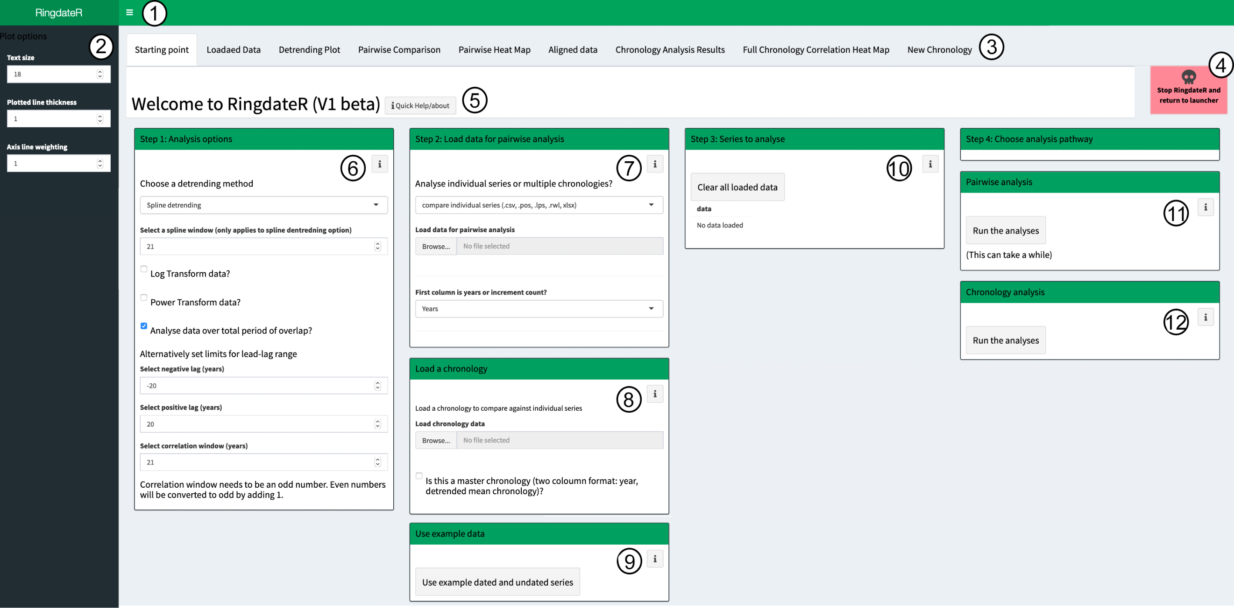

**Fig 1:** A screen shot of the RingdateR Starting Point. 1) The three-line icon is a clickable button that toggles an options menu (2) that contains settings that control the display settings for all the plots in RingdateR (text size and line thickness). 3) A navigation bar that facilitates the movement between different parts of the RingdateR programme. 4) A button that stops the analysis and quits RingdateR. 5) A Help button. These buttons are dotted throughout RingdateR and initiate a popup box that contains information pertaining to the respective box containing the button. 6) The Analysis Options taskbar allows the user to define the parameters for the analysis. Options in this menu include detrending options, lead-lag limits and correlation windows (for running correlation analysis). 7) The load data for pairwise analysis taskbar allows the user to upload either a single file containing all the individual series or multiple files each containing data for an individual series. 8) The load chronology taskbar allows a user to upload a file containing the non-detrended date aligned series (e.g. a chronology). 9) The example data box allows the user to utilise preloaded data. Clicking the Use example data button loads data for both the Pairwise and Chronology Analysis Modes. 10) The series to analyse taskbar displays the series names for all of the individual series to be analysed in either Pairwise or Chronology Analysis Modes. The clear data button allows all loaded data to be deleted, this also clears the example data. 11 and 12) The Pairwise Analysis and Chronology Analysis taskbars, and corresponding buttons, launch the pairwise and chronology analysis modes respectively. These buttons will start the analysis and then jump straight to the corresponding results pages.

RingdateR can operate in two modes, Pairwise Analysis Mode and Chronology Analysis Mode. The Pairwise Analysis Mode is designed to facilitate the comparison of multiple measurement series against each other (e.g. multiple ring width series from individual trees). Series loaded into the Pairwise Analysis Mode can either have known dates (i.e. modern live-sampled specimens) or be of unknown antiquity (i.e. fossil material). Chronology Analysis Mode, on the other hand, is designed to facilitate the comparison of individual measurement series against an existing mean chronology.

Fig. 2 sets out the analysis pathway for both the Pairwise and Chronology Analysis Modes. Both approaches follow the same process, that once the data is loaded, the series are detrended before lead-lag correlation analysis is conducted. During the analysis process, it is possible to evaluate the stability of the correlations through time between specific samples using running lead-lag correlation heat maps. Significance tests are then applied to determine the probabilities associated with potential crossdates. Finally, samples that pass the statistical tests can be aligned in time, either relative to each other, in Pairwise Analysis Mode, or relative to the existing mean chronology, in Chronology Analysis Mode. These data can then be saved in a variety of different formats.

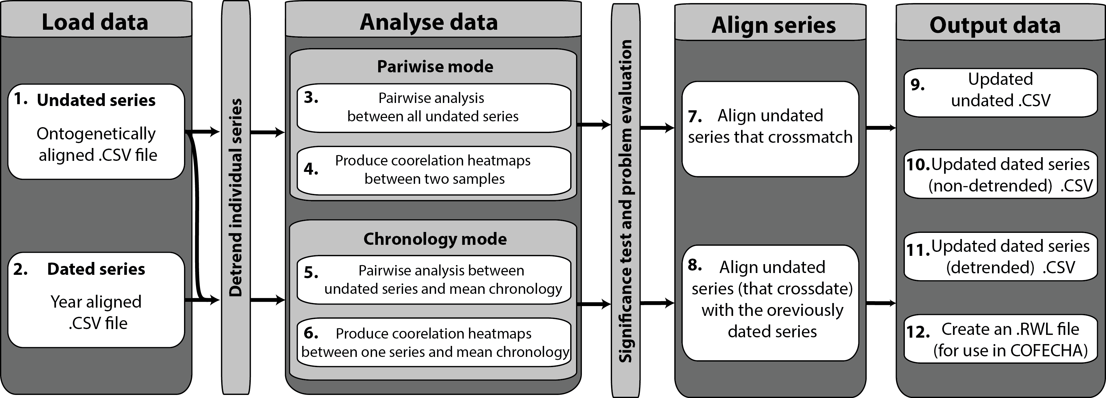

**Fig 2:** Schematic of the RingdateR workflow. RingdateR is split into four stages, with the starting point being the loading of the data (1 and 2) and selecting the analysis options. The data are then detrended before being analysed either through the Pairwise Mode (3 and 4) or the Chronology Mode (5 and 6). If significant crossdates are found, the user has the option to align the series that pass the significance tests (7 and 8). Finally, the user has the option to remove the newly dated series from the undated file that was originally uploaded and create a new CSV file with the remaining undated timeserires (9). It is also then possible to save the aligned crossdated timeseries as non-detrended or detrended CSV files (10 and 11 respectively) or create an RWL file (12) to transfer the analysis to other programmes such as COFECHA.

As methodologies for running RingdateR in Pairwise and Chronology Analysis Modesare similar, for brevities sake in the descriptions below, we therefore characterise both approaches as comparing two samples. This could therefore mean, for instance, comparing two individual undated series against each other in Pairwise Analysis Mode, or comparing an individual series against an absolutely dated chronology in Chronology Analysis Mode. In reality, when large numbers of series are loaded into RingdateR each of the approaches outlined below would be conducted as part of a loop to ensure that every series is analysed, either against each other series or against the mean chronology. Whilst there are no defined limits on the number of individual measurement series that can be loaded into RingdateR, loaded files must not be bigger than 50mb. It is worth noting though, that the more samples that are loaded the longer the analyses will take to compute. Actual computation times are dictated by individual computer specifications and the availability of server space at the time of use for the offline and online versions of RingdateR respectively.

**3. Loading data**

The RingdateR Starting Point page contains two “Browser” buttons that allow a user to load measurement series or a chronology into RingdateR. The first browser button (in the load data for pairwise analysis box) facilitates the loading of either a single file that contains multiple measurement series (in either xlsx, csv or rwl formats) or multiple files as two column text delimited files or measurement files from Image Pro and CooRecorder. The sections below (3.1-3.2) provide information on the different file types that RingdateR supports and some tips to reduce the chance or errors.

RingdateR provides summary tables of all the data that has been loaded on the Loaded Data page. If a large number of series have been loaded, it is worth checking these tables prior to running the analyses to ensure all the data is loaded correctly. RingdateR performs some basic checks (orientation, resolution, missing values, empty columns etc) on the loaded data to make sure there are no obvious issues with the loaded data. An error message will pop up on the screen if RingdateR detects an issue. If an error does occur when running RingdateR, the screen will likely go grey. If this occurs refreshing the page will restart RingdateR.

RingdateR comes preloaded with an example dataset that can be used in both the Pairwise and Chronology Analysis Modes. Clicking the Load Example data button loads the data for both analysis pathways. To run RingdateR with the example data simply click load example data button. When the data is loaded the Series to analyse box will contain a list of sample IDs. Then, click on either of the Run the Analysis buttons in the Pairwise Analysis Mode or Chronology Analysis Mode boxes.

**3.1 Loading data in the Pairwise Analysis Browser.**

Data can be loaded into the Pairwise Analysis Mode in two principal formats: multiple series compiled into a single file, or individual series in individual files. RingdateR also accepts a variety of different file types (Excel [.xlsx], comma separated values [.csv], text delimited (.txt), Ring width files [.rwl], CooRecorder measurement files [.pos], Image Pro line profiles [.lps]). For a full description of the requirements for each format and file type see the supplementary methods see the following sections.

**3.1.1 Using Excel and Comma Separate Value files (.xslx and .csv)**

Excel (.xlsx) and comma separated value (.csv) files can be used to load in compiled data (a single file containing multiple measurement series). These files should be formatted such that the first column contains either a year value or ring number (in ascending order; e.g. Table 2). Each of the following columns should contain a uniquely named measurement series. The first row of the file should contain the sample IDs.

The compiled files can contain missing values (either as blank or NA values). However, missing values cannot be situated within a measurement series. They can, however, be at the start and end of series (e.g. Table 2 A).

Table 2: Compiled data sets can either be loaded in as (A) date aligned or (B) ontogenetically aligned data.

|  |  |  |  |  |  |  |  |  |
| --- | --- | --- | --- | --- | --- | --- | --- | --- |
| A |  |  |  |  | B |  |  |  |
| Year | Series_1 | Series_2 | Series_3 |  | Ring | Series_1 | Series_2 | Series_3 |
| 1901 | NA | NA | 0.45 |  | 1 | 0.51 | 0.06 | 0.45 |
| 1902 | NA | NA | 0.99 |  | 2 | 0.34 | 0.76 | 0.99 |
| 1903 | NA | 0.06 | 0.20 |  | 3 | 0.02 | 0.13 | 0.20 |
| 1904 | NA | 0.76 | 0.08 |  | 4 | 0.64 | 0.78 | 0.08 |
| 1905 | NA | 0.13 | 0.33 |  | 5 | 0.26 | 0.64 | 0.33 |
| 1906 | 0.51 | 0.78 | 0.38 |  | 6 | 0.57 | 0.09 | 0.38 |
| 1907 | 0.34 | 0.64 | 0.01 |  | 7 | 0.76 | 0.77 | 0.01 |
| 1908 | 0.02 | 0.09 | 0.41 |  | 8 | 0.52 | 0.64 | 0.41 |
| 1909 | 0.64 | 0.77 | 0.83 |  | 9 | 0.60 | 0.08 | 0.83 |
| … | … | … | … |  | … | … | … | … |

**3.1.2 Using two column format files (.txt).**

Multiple two column format text delimited files (.txt; containing a year column and single column of measurement values) can be loaded into RingdateR. The data from each file is aligned with respect to date. Each file should not contain more than one measurement series. The file names are used as the sample IDs.

**3.1.3 Using Image Pro Line Profile Series files (.lps)**

Measurement series created in Image Pro as a line profile series can be directly imported into RingdateR. The .lps files can contain more than one line profile. RingdateR will automatically detect that more than one measurement series is in the file and load them as separate measurement series with the sample ID file_name_l1, file_name_l2 etc. The .lps files contain cumulative growth data. Therefore, RingdateR converts the cumulative growth data into absolute growth increment series for use in the Pairwise or Chronology Analysis Modes.

RingdateR automatically detects that an .lps file has been loaded and will allow users to then load multiple .lps files. Note that it is not possible to load both .lps and .excel or .csv files at the same time. The system is designed to load either multiple .lps (or .pos files) or a single .xlsx or .csv file. When multiple lps files are loaded RingdateR compiles the data into a single data frame. The series in the data frame are aligned by ontogenetic age with the file name (excluding the extension) as the sample ID number (e.g. Table S2 B).

Figures 3-5 show the process of creating .lps files in Image Pro for use in RngdateR.

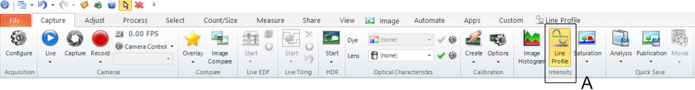

Fig 3: To start the Line profile series, once an image has been loaded and calibrated in Image Pro, use the Line Profile tool which is accessed on the Create tab of the file menu system (box A).



Fig 4: When using the line profile tool, the Manual measurement option (box A) provides the most consistent results for creating measurement series that can be incorporated into RingdateR.

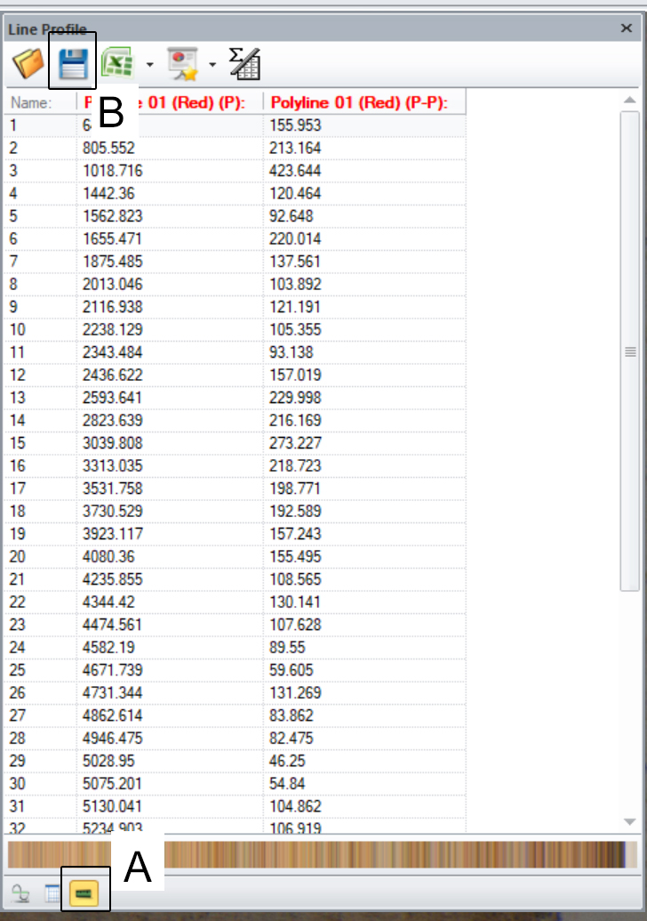

Fig 5: When saving the .lps file ensure that the results window is set to the third tab (Box A: displays the cumulative growth measurements in the first column). The save icon (box B) will then allow you to save the measurements as an .lps file.

**3.1.4 Using CooRecirder files (.pos)**

As each .pos file contains measurements from one series, multiple .pos files can be loaded. These files can then be used in either the Pairwise or Chronology Analysis Modes. As no date values are included in .pos files, when the files are loaded into RingdateR, all of the data are aligned relative to the first measurement of each line.

**3.2 Loading data for Chronology Analysis Mode**

Chronologies can be loaded into the Chronology Analysis Mode either in multi-column format, with a file containing the individual series used to construct the chronology (in either .rwl or .csv formats) or as a two column file (years/mean chronology) as a .csv file. The data in multi-column format files are detrended with the same methodology as the individual series loaded through the Pairwise Analysis browser menu.

It should be noted that if a user intends to use the Chronology Analysis Mode, the individual measurement series that are to be compared to the chronology must be loaded via the Pairwise Analysis browser menu. The chronology data is then loaded via the Load a Chronology browser.

**4. Detrending**

RingdateR includes seven options for detrending the individual series to be used in the Pairwise and Chronology Analysis Modes. Firstly, the “Do nothing to my data” option applies no detrending to the loaded data. Secondly, whilst not technically detrending, the data can be converted to z-scores. Z‑scores are created using the scale(data, center = T, scale = T) function. The spline, modified negative exponential, Friedman and modified Hugershof detrending curves are applied using the detrend.series function in the dplR package (Bunn et al., 2010). The first difference of the measurement series is the final detrending approach available. The first difference of the data is generated by calculating the difference between measurement years (I.e. inter-annual variability). For the spline, modified negative exponential, Friedman and modified Hugershof detrending methods, detrended series are calculated by dividing the measurement series by the detrending curve. This approach helps to standardise variance through the timeseries. In addition, it is possible to apply adaptive power transformations.

A 21 year spline is set as the default detrending method in RingdateR. Adjusting the length of the spline can lead to a greater/lesser proportion of lower frequency variability being removed from the measurement series.

Once data has been loaded, it is possible to evaluate the impact of the detrending options before committing to run any analysis by viewing the detrended data on the Detrending Plot page. On the Detrending Plot page it is possible to view the impact of the selected detrending options on each individual sample loaded through the Pairwise Analysis loading browser. If the selected detrending method is not suited, it is possible to navigate back to the starting point page and select an alternative detrending option.

**5. Crossdating**

As set out in Fig. 2, crossdating in RingdateR is a multi-step process. After initialising the analysis by clicking either the Pairwise or Chronology Analysis Mode Run the Analysis Mode buttons, RingdateR will go through a two-step process. Initial crossdating is conducted using lead-lag analysis (See section 5.1) followed by running lead-lag correlation analysis (Section 5.2). Once the lead-lag analyses have been conducted and the running lead-lag correlation analyses are displayed for the selected samples, the user has the option to filter results by statistics and by sample ID. Once the results table is filtered, users have the option to evaluate the stability of the correlations through time between samples that pass the initial statistical tests (Problem Sample checker; section 5.3). More details on each of these steps are provided in sections 5.1-5.3 respectively.

**5.1 Lead-lag Analysis**

RingdateR uses conventional lead-lag analyses to quickly identify potential matches between series. The lead-lag analyses generate a data frame (table) containing a single correlation coefficient, T-test statistic, probability and overlap length (years) between the two samples for each positive and negative lag. The default setting in RingdateR is to evaluate all possible leads and lags between samples. However, it is possible to constrain the lead-lag limits on the starting page to a smaller range.

Given large numbers of analyses can be conducted during lead-lag analysis, a Bonferroni correction is applied to the probability values for each of the lead-lag analyses. The Bonferroni correction applied is derived based on the total number of correlations calculated between two samples, which is dictated by the total range of lags evaluated. This approach was taken as it provides a more conservative approach compared to applying a Bonferroni correction based on the number of individual series being analysed.

The lead-lag analysis results are displayed in full as a bar graph (displayed for each comparison separately; Fig 6) and in summaries as part of the large and small results table at the base and top right corner of the results pages respectively. It should be noted that, to save screen space, only the positive correlations are plotted as part of the bar graph (Fig 6). The lead-lag correlation results are plotted in the bar graph as T-test statistics as T-test statistics are less influences by edge effects, which can lead to inflated correlation coefficients.

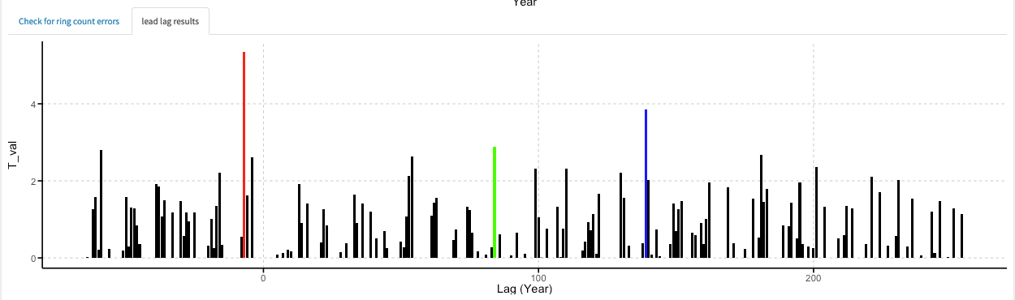

**Fig 6:** A Bar graph highlighting T-test statistics for lag years containing positive correlations. The red, blue and green lines highlight the best, second best and third best matches respectively.

**5.2 Running lead-lag Correlation Analysis**

Running lead-lag correlation analysis provides a powerful tool for evaluating the stability of correlations through time and identifying potential problems with measurement series (e.g. Fig 7). Such techniques have been used in sclerochronology over the past decade to facilitate the construction of both absolutely dated and floating chronologies extending over past centuries to millennia e.g. (Scourse et al., 2006, Butler et al., 2010, Butler et al., 2013). However, computing running lead-lag correlation analysis over all possible leads and lags between long-lived samples is computationally expensive. To mitigate this issue, RingdateR optimises the approach by performing the running lead-lag correlation analysis over a defined window (±10years) centred on the lag identified by the conventional lead-lag analysis as the most probable crossdate (Fig 7). Users then have the option to modify the lags plotted in these analyses to view alternative probable matches or indeed a custom lag selection. RingdateR also provides the facility to generate running correlation heat maps over the entire period of overlap between two samples if desired (using the Full Heat Map and Full Chronology Heat Map pages).

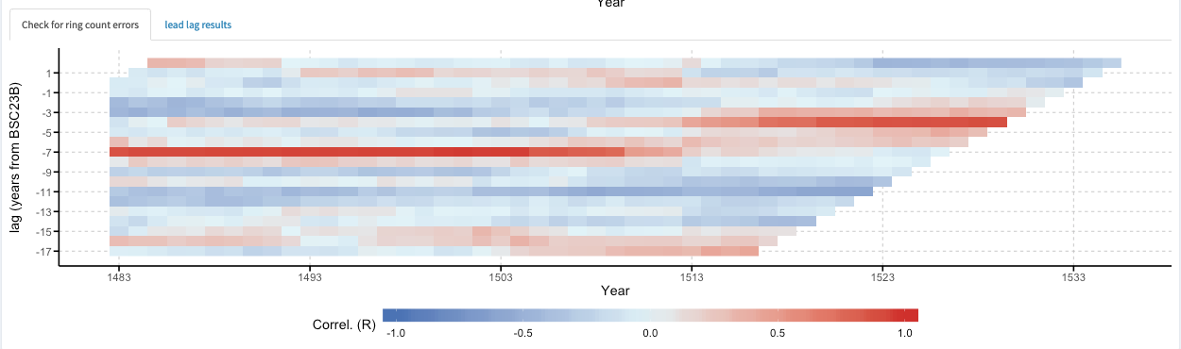

Fig 7: A correlation heat-map displaying the results of running lead-lag correlation analysis between two samples. Positive (negative) correlations are highlighted by a strong red (blue) colour. The break in the solid red line at -7 year lag (ca. 1513) to a lag of -5 years indicates there is likely an error in the measurement series analysed.

**5.3 Checking for Problematic Samples**

For series which pass the statistical tests (set up by applying the Statistical Filter in Step one of both the Pairwise Analysis and Chronology Analysis Results pages) RingdateR provides the facility to automatically evaluate if there may be any “problematic” samples. In Pairwise Analysis Mode the Filter by Series Name: Filter using series 1 option must also be selected. Using this series ID filter ensures that each sample will only be included once in the arithmetic mean chronology used to evaluate for problematic samples.

To evaluate for problematic samples, the series are aligned in time and an arithmetic mean chronology calculated. RingdateR then utilises the corr.rwl.seg function from the dplR package to evaluate if individual series exhibit instabilities in their correlation with the mean chronology (Bunn et al., 2010). The corr.rwl.seg evaluates the strength of the correlation between each series and the mean chronology over set running windows with a 50% overlap between each window.

Samples can be flagged as problematic for two principal reasons. Firstly, If the series contains a missing or falsely identified ring (or rings), the series will contain a shift in the timing (lag) of peak correlation between windows (similar to that shown in Fig. 7 above). Secondly, the correlation between the sample and the mean chronology could be variable through time. These fluctuations in the strength of the correlation may not necessarily mean that there is a problem with the measurement series. It could imply that the sample just does not reflect the mean chronology over that defined interval. The Problem Sample Check is merely designed to flag potential problems and therefore takes a conservative approach. The images and corresponding measurement series should be checked for any sample that is flagged as a problem.

These analyses are highly sensitive to the bin size that is used to perform the analysis. It is therefore recommended that these analyses are replicated using multiple window lengths. This can be done simply by changing the window length in the Step 3 box (Fig. 8) on both the Pairwise Comparison Results page or the Chronology Analysis Results page and pressing the Check for problematic samples button. This can be done as many times as the user desires.

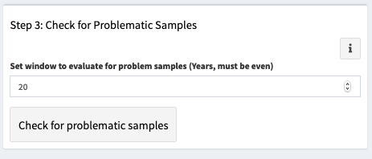

Fig 8: The Step 3 box allows the user to evaluate if there are instabilities in the strength of the correlations between each sample and the mean chronology through time.

In the Pairwise Analysis Mode it is possible to perform a secondary evaluation for problematic samples on the Aligned Data page. This process provides an opportunity to perform more in-depth analysis of the identified problematic samples against the mean chronology constructed using only samples that have not been identified as problematic. More details are provided on this analysis in section 6.1.

**6. Aligning samples**

In both Pairwise and Chronology Analysis Modes, samples that have been found to significantly crossdate can be aligned either against each other, in Pairwise Analysis Mode, or against the chronology, in Chronology Analysis Modes. In both Pairwise and Chronology Analysis Modes the large results table must first be filtered by statistics (Step one). This is because RingdateR uses the information in the large results table to perform the alignment process.

In the Pairwise Analysis Mode, the large results table must also be filtered by series ID (using the Series one option). Doing this ensures that each sample can only be in the table once and therefore will be added to the aligned data series once. Filtering by sample ID is not required in the Chronology Analysis Mode as each series that is correlated against the chronology is already only in the table once.

Finally, before the alignment process can be started, the Problem Sample Check must be completed (Step 3). Once these steps have been completed, the user can select, using the options available in the Step 4 box (Fig 9), whether all the samples in the large results table will be aligned, either including or excluding problematic samples, or a manually selected subset of the samples.

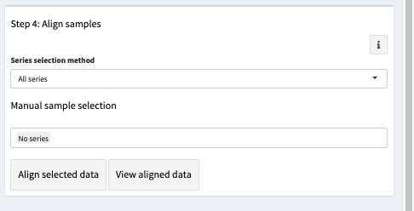

Fig 9: The step 4 box of both the Pairwise and Chronology Analysis Modes allows users to select date to align by calendar date.

The Aligned Data and New Chronology pages display the results of the alignment process for both the Pairwise and Chronology Analysis Modes respectively (Fig 10). Whilst RingdateR is not a chronology construction application, these pages facilitate the evaluation of the common signal amongst the samples that have been aligned. This is done through the evaluation of the running mean correlation between all of the series aligned (Rbar) and the expressed population statistic (EPS). Both the Rbar and EPS statistics are calculated using a default 25-year window with a 50% overlap. The length of the window can be adjusted using the options menu displayed on the right of the page. The Rbar and EPS analysis are conducted using the rwi.stats.running function from the dplR package (Bunn et al., 2010).

In addition to the Rbar and EPS statistics, RingdateR evaluates the mean correlation between each sample and the arithmetic mean chronology with replacement (i.e. the correlation between each sample and the mean chronology constructed excluding the sample being correlated against it). These correlations are provided in a table at the bottom of the Aligned Data and New Chronology pages.

In both the Chronology and Pairwise Analysis Modes, it is possible to move back and forth between the main results pages and the aligned data pages. This allows for the valuation of, for instance, the impact of including samples that have been flagged as problematic into the chronology. In addition, in the Aligned Data page of the Pairwise Analysis Mode, RingdateR provides the option to perform a secondary problem sample check. If problematic samples are found it is then possible to compare these series against the mean chronology constructed using only samples that have not been flagged as problematic (see section 6.1)

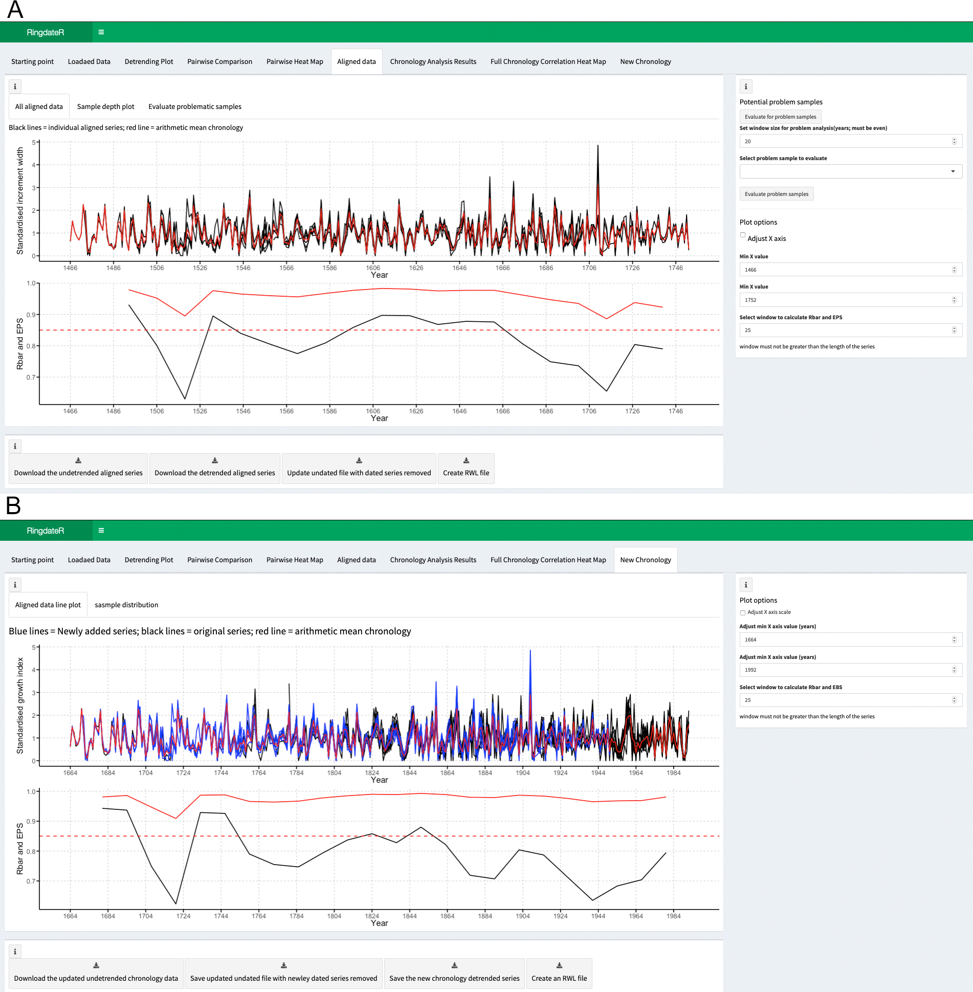

**Fig 10:** A) The Aligned Data and B) New Chronology Pages for the Pairwise and Chronology Analysis Modes Respectively. The upper panels in both panels (A and B) show line graphs displaying the individual measurement series (black and blue lines) that have been aligned and the mean chronology (red line). The line plot for the Chronology Analysis Mode displays the individual measurements for the original series contained in the chronology (black lines) as well as the measurement series of the newly aligned series (blue lines). The lower panel plots in both panels (A and B) display the running Rbar and expressed population statistics (EPS) calculated over a running window with a 50% overlap between bins. The window size used to calculate the Rbar and EPS statistics can be modified in the control panel on the right of the page.

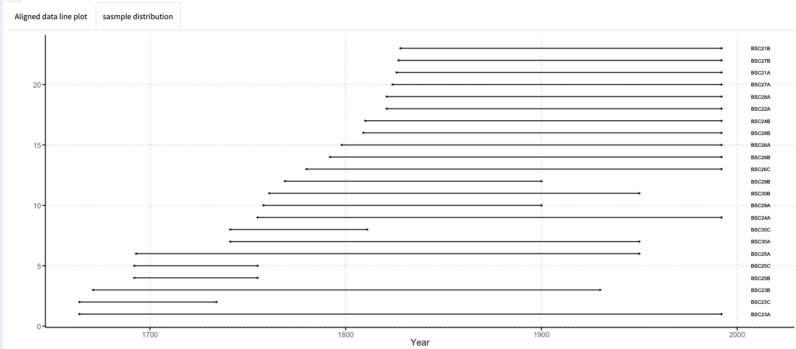

**Fig 11:** Plot showing the distribution of each of the series that have been aligned through both the Pairwise and Chronology Analysis Modes.

**6.1 Pairwise Analysis Mode problem sample evaluation**

The Pairwise Analysis Mode facilitates a secondary evaluation of whether the series that have been aligned through the Pairwise Analysis Mode contain any problems (missing/false rings or unstable correlations). The secondary analyses are conducted in the same manner as the primary problem sample checker (see section 5.3). However, unlike on the Pairwise Results page, conducting the Problem Sample Check on the Aligned Results page allows users to then analyses the samples that are identified as problematic samples against the arithmetic mean chronology constructed excluding the samples that have been identified as problems.

To evaluate for problem samples, simply select the window length from the panel on the right and click the evaluate for problem samples button. If any problem samples are identified, a small table will appear containing the sample ID and the interval that has been identified as a problem. The sample IDs will also then appear in the dropdown menu allowing the sample to be evaluated against the mean chronology (Fig 12). In addition, the sample depth plot, that ordinarily shows the position of each sample with a black line (Fig. 11) will be updated to highlight the position of samples that may contain a problem (highlighted red; Fig. 13).

If a sample has been aligned despite the fact that there are missing/false rings in the series, it is possible to go back to the results page and omit that sample from being aligned with the rest of the data.

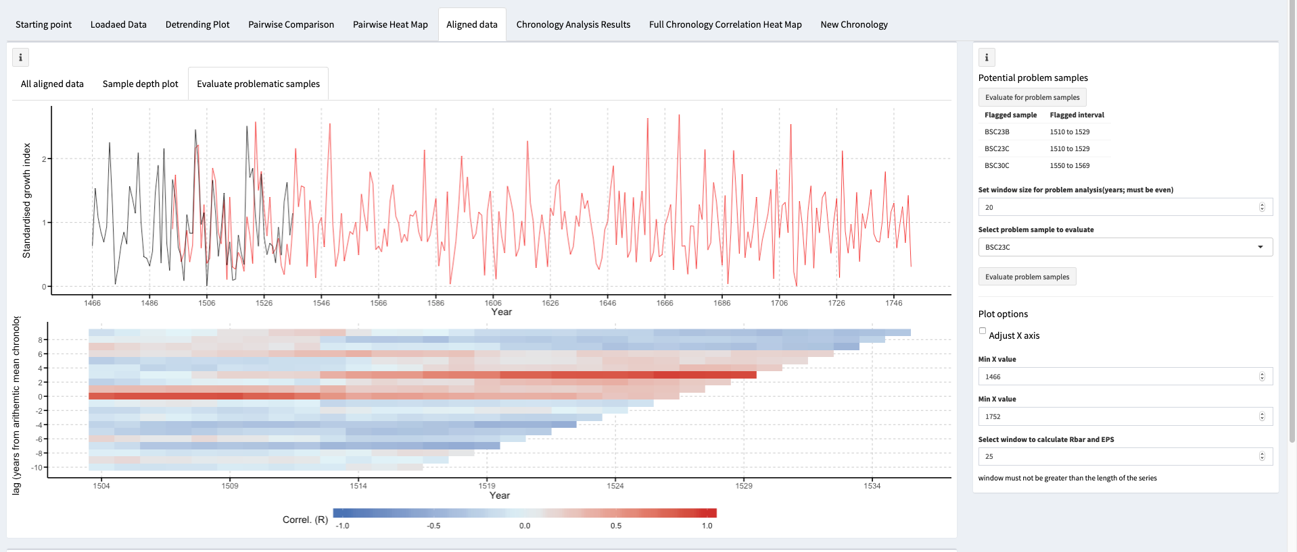

**Fig 12.** A screenshot showing the Evaluate Problematic Sample tab on the Aligned Data page of the Pairwise Analysis Mode. The Page displays the mean chronology constructed excluding the problematic sample (red line) as well as the measurements for the problematic sample (black line). The lower panel shows the corresponding running lead-lag correlation heatmap.

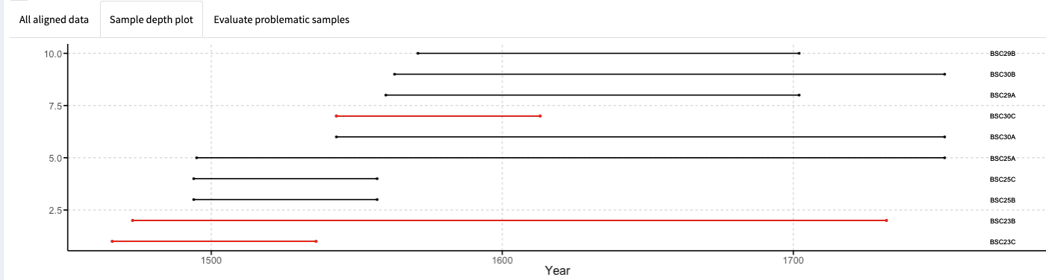

**Fig. 13:** Plot showing the distribution of each of the aligned samples through time on the Aligned Data page of the Pairwise Analysis Mode. Problematic Samples are displayed as a red line.

**6.2 Saving Data**

RingdateR facilitates the download of both plots and data. The exact process this takes will vary depending on the browser that is being used to run RingdateR. Some browsers, for instance, will open the files directly into excel. Other browser however, will save the data into the downloads folder on the user’s computer.

Some plots have corresponding download buttons that allow them to be directly downloaded. However, the easiest way to save a figure is to right click on it and click “Save Image As”. This will save the figure at the same size and resolution as using the download buttons but allow the user to save he image exactly where they want it. Using the download buttons results in the images being saved to the Downloads folder on the user’s computer. Image resolution and size will be the same using both saving methods.

Crossdating results can be saved using the Download Results Table buttons on the Pairwise and Chronology Results pages respectively. These data are saved as .csv files.

On the Aligned Data and New Chronology pages, there are four buttons for downloading the newly aligned data as well as updating the compiled file that contains the individual series. The aligned data can be downloaded in three formats, two of which contain undetrended data and the third containing detrended data. The undetrended aligned data can be saved as either a .csv file or a .rwl file. The detrended aligned data can only be saved as a .csv file. Finally, it is then possible to save an updated version of the file that was originally loaded into the Pairwise Mode. This updated individual series file, contains the series that were not crossdated or aligned. This file is saved as a .csv file. If multiple files were loaded into the Pairwise Browser, the updated individual series file will download a compiled file containing the measurement series not aligned.

**7. Alternative ways to use RingdateR**

**7.1 Using RingdateR to compare multiple chronologies**

Whilst it is was not our intention, RingdateR can also be used to evaluate correlations between multiple chronologies. This can be achieved in two ways, both of which utilise the Pairwise Analysis Mode and NOT the Chronology Analysis Mode.

Firstly, each of the chronologies that are to be compared, can be compiled into a single file (e.g. .csv or .xlsx). Using this method, the option to compare individual series, (and not compare multiple chronologies) should be selected. This file should be organised such that the first column contains dates in ascending order and then each following column contains an individual mean chronology. Before starting the Pairwise Analysis Mode, ensure that the detrending option in RingdateR is set to “Do nothing to my data”. This will ensure that no additional detrending is applied to the chronology. If the detrending option is set to another option, the chronologies will either be detrended a second time, or an error may occur. Pairwise Analysis Mode can then be started. The advantage with this approach is that more sophisticated methodologies for compiling chronologies can be used as RingdateR is not compiling the chronology. This would allow, for instance, chronologies constructed with signal free detrending to be analysed.

Secondly, each chronology can be loaded as an independent .rwl file. To do this, ensure the option to Compare multiple chronologies is selected. Each file should then be loaded individually using the Pairwise browser. To load multiple files simply re-click the browser button once the first file has loaded successfully. Once loaded, the ring width data in each .rwl file will be detrended using the settings defined in the Step one: Analysis Settings box on the Starting Point Page. It is important that the detrending settings are defined before the data are loaded, as each file is detrended as soon as it is loaded. RingdateR calculates the arithmetic mean chronology for each file loaded. There is no limit to the number of chronologies that can be loaded. The advantage with this approach is that you don’t need to compile the data before loading it into RingdateR. The disadvantage however is that RingdateR will only use an arithmetic mean to compile the chronologies.

**Appendix I: A detailed view of how the code operates.**

This appendix gives a brief summary of the core code that runs RingdateR

**Data storage:**

All data loaded and created in RingdateR are stored as Reactive Value dataframes. These essentially act as regular dataframes in R, however they are easily modified within the Shiny framework.

loading <- reactiveValues ( df_data = data.frame(NULL))

chron_loading <- reactiveValues ( df_data = data.frame(NULL))

lps_loader <- reactiveValues ( df_data = data.frame(c(1:500)) )

undated <- reactiveValues ( df_data = data.frame(c(1:500)) )

chrono <- reactiveValues ( df_data = data.frame(c(1:500)) )

analysis.data <- reactiveValues ( df_data = data.frame(c(1:500)) )

master_lead_lag <- reactiveValues ( df_data = data.frame(NULL))

master_chron_lead_lag <- reactiveValues ( df_data = data.frame(NULL))

**Detrending**

A<- detrend.series(series_data[,series_a], method = "Spline", nyrs= splinewindow, make.plot = F, pos.slope =T)

**Generating arithmetic mean chronology for dated series**

chron_mean <- rowMeans(dtnd.chron[,-1], na.rm = T)

where *dtnd.chron* representants the detrended individual series contained in the dated chronology. The [,-1] command excludes the year column from being included in the calculation.